UDC 577.3 (see https://udcsummary.info/php/index.php)

PAPER TITLE
1st Name Surname^{1,}* , 2nd Name Surname², 3rd Name Surname²
¹ Dept. name of organization, name of organization, building number Street name, City, Index, Country
² Dept. name of organization, name of organization, building number Street name, City, Index, Country
*Corresponding author: e-mail@gmail.com
Submitted Month (in words) Day (in numbers), in numbers

Background: State the relevance of your work. Text 10 pt…
Objectives: Define the purpose of the work. Text 10 pt …
Materials and methods: Specify the materials and methods used. Text 10 pt …
Results: Describe the results you have obtained. Text 10 pt …
Conclusions: Summarize the conclusions. Text 10 pt …
KEY WORDS: Type 5–8 key words, separated by a semicolon, text 10 pt; e.g. concentration; temperature; protein; DNA; gamma-irradiation.

A manuscript should be typed in single spacing on A4 paper. Use the MS Word with following options: 12 points Times New Roman font, text justified. Left and right margins should be 2.5 cm, the upper margin should be 3.5 cm, and bottom one should be 2 cm.
Insert UDС in the first line on the left of a first page (11 pt, Italic). Leave one line blank. Place the title of the paper in capital letters (12 pt, bold, centered) on the next line. After one blank line type initials (names) and surnames of the authors (12 pt, bold, centered). On the next line type the authors' affiliation and postal addresses of the institution where the actual work was done, including an e-mail address of the corresponding author (10 pt, Italic, centered).
Then, place the date of the paper submission: day — in numbers, month — in words, year — in numbers (straight font, 10 pt, centered).
The abstract should be structured and consist of the following parts with headings: Background, Objectives, Materials and Methods, Results, Conclusions, each placed on a new line. The word "Abstract" should be omitted. The headers of structural parts are written in bold letters, putting a dot after the header. The two abstracts of the paper should contain not less than 1,800 and not more than 2,000 phonetic symbols (i.e., without taking into account the spacing between words); straight font, 10 pt. On the next line type 5–8 key words, separated by a semicolon (10 pt — first abstract, 9 pt — second and third abstracts). Next, the header "KEY WORDS:" should be typed in bold capital letters at the beginning of the line. The texts of the abstracts and key words should be indented 0.5 cm from the left and right margins. The abstracts should be separated by a blank line.
Then, leave one blank line before starting to type the text of the paper with following options: Times New Roman font, 12 pt, text justified. The first line of each paragraph should be indented 0.75 cm from the left margin. Each manuscript should contain the following elements: an introduction (heading of this section should be omitted), MATERIALS AND METHODS (obligatory for experimental studies), RESULTS AND DISCUSSION, CONCLUSIONS. For theoretical less specified text organization is envisaged, e.g., instead of section MATERIALS AND METHODS, the sections PROBLEM FORMULATION or MODEL are recommended, etc. The sections are not numbered, capital letters, bold, centered. Sections may be subdivided into subsections, if necessary. Subsection Headings are centered and should be bold and capitalized. Leave one blank line after each section or subsection. A dot should be omitted after headings of sections and subsections. Names of the foundations and grant numbers should be included in the section ACKNOWLEDGMENTS at the end of the text after one blank line. The next section should be CONFLICT OF INTEREST in which you should declare financial or any other conflict of interest. If there is no conflict of interest, you can state: “The authors declare that there is no conflict of interest.” The next section should be Authors’ ORCID ID in which you should include ORCID internet addresses of all authors.

MATERIALS AND METHODS
Specify the materials and methods used.

RESULTS AND DISCUSSION
Describe the results you have obtained. Add a discussion. Mathematical and chemical symbols, equations, and formulae should be inserted in the text by computer means (MathType or Microsoft Equation). Figures should be computer-generated in software packages intended for processing and visualization of scientific data: Origin, Mathcad, etc. The use of the MS Office Excel is not recommended. Use computer printed symbols for axes labeling. Insert prepared images into an MS Word file as files in *.emf, *.wmf, *.jpg, *.jpeg, *.png format within the area of the page specified above.

Fig. 1. A figure caption. Text 10 pt. Pay attention to the size of the fonts in the figure legends and labels. Label all axes. Label all curves and data sets. They should be no smaller than 9 pt.
Figure Labels: Use 9 point (or more) Times New Roman for Figure labels. Use words rather than symbols or abbreviations when writing Figure axis labels. As an example, write “Temperature, °С”, or Temperature (°С).

We recommend the following layout: images are placed in the first row of the table with transparent outer borders, legends and comments to figures are placed in the second raw of the table. The font size of figure legends should be no smaller than 9 points. Formulae, tables, figures should be numbered consecutively using Arabic numerals, e.g. (1), Table 1, Fig 1, Fig. 2.
. (1)

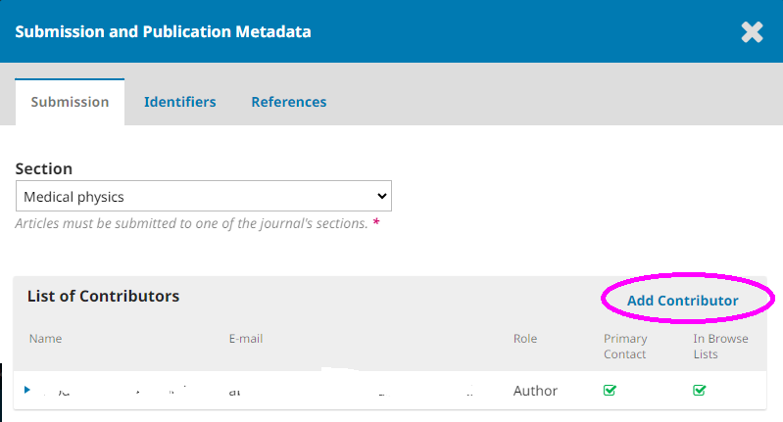
Fig. 2. If your article has more than one author, please list all authors on the submission form. Submissions that do not meet this requirement will not be considered!

Table 1. Clear and concise legend/caption. Units are provided.

Table column head | Table column head
1 | 2

References to the literature should be cited in the text consecutively by Arabic numerals in square brackets, e.g. [1]. The citation of unpublished papers, textbooks and tutorials are prohibited. List of references (10 pt) should be given at the end of the manuscript as a separate section REFERENCES, formatted according to the Vancouver style for scientific publications.
The examples for reference formats are given on the journal's website in the "Author Guidelines":
https://periodicals.karazin.ua/biophysvisnyk/about/submissions.

Manuscripts that do not meet the requirement mentioned above will not be considered for publication!

CONCLUSIONS
Summarize the conclusions.

ACKNOWLEDGMENTS
Names of the foundations and grant numbers should be included in the section.
CONFLICT OF INTEREST
The authors declare that there is no conflict of interest.

Authors’ ORCID ID
1st Name Surname http://www.orcid.org/XXXXXXXXXXX
2nd Name Surname http://www.orcid.org/XXXXXXXXXXX

REFERENCES
1. Sear RP. Diffusiophoresis in cells: A general nonequilibrium, nonmotor mechanism for the metabolism-dependent transport of particles in cells. Phys. Rev. Lett. 2019 Mar 29;122(12):128101. https://doi.org/10.1103/PhysRevLett.122.128101
2. Bondarenko MA, Knigavko VG, Gordiyenko NO, Zaytseva OV, Kocharova TR. Mathematical modelling of distribution of genes the damage of which leads to oncologic diseases in human population. Bіophysical bulletin. 2016;35(1):5–9. (In Ukrainian).
3. Carlson BM. Human embryology and developmental biology. 4th ed. St. Louis: Mosby; 2009. 541 p.
4. Ettinger S. Nutritional pathophysiology of obesity and its comorbidities: a case-study approach [Internet]. Amsterdam: Academic Press; 2017 [cited 2019 Aug 20]. 334 p. https://doi.org/10.1016/C2014-0-04074-9
5. Acree W, editor. Toxicity and Drug Testing. InTech; 2012. 528 p. https://doi.org/10.5772/1976

For searching doi links use this resource: https://doi.crossref.org/simpleTextQuery
Write “https://doi.org/10.5772/1976”, not “DOI: 10.5772/1976”, not “http://dx.doi.org/10.5772/1976”

If your article has more than one author, please list all authors on the submission form. Submissions that do not meet this requirement will not be considered!

НАЗВА СТАТТІ
Ініціали (Ім’я) Прізвише¹, Ініціали (Ім’я) Прізвище ², Ініціали (Ім’я) Прізвище ²
¹Харківський національний університет імені В.Н. Каразіна, майдан Свободи, 4, Харків, 61022, Україна
³Фізико-технічний інститут низьких температур ім. Б. І. Вєркіна НАН України,
пр. Науки, 47, Харків, 61103, Україна
e-mail: e-mail@gmail.com
Надійшла до редакції ...
Прийнята до друку ...

Актуальність. Викладіть актуальність роботи.
Мета роботи. Визначте мету роботи
Матеріали і методи. Зазначте використані матеріали і методи.
Результати. Опишіть оримані результати.
Висновки. Сформулюйте висновки.
КЛЮЧОВІ СЛОВА: біофізика; правила для авторів; стаття.

